6.19: a) From Eq. (6.5), 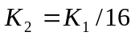, and from Eq. (6.6), 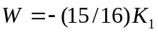. b) No; kinetic energies depend on the magnitudes of velocities only.

